**TASK REPORT: AURASENSE – A MOOD TRACKING WEB APPLICATION**

**Submitted by:** Sivathmika C  
**Date:** 15-04-2025

**Project Overview:**

The AuraSense Mood Tracker web application allows users to track and analyze their daily mood, stress, energy levels, sleep patterns, nutrition, physical activity, and emotional reflections. It also helps users stay connected with their well-being by reflecting on gratitude. The application provides an option for dark mode and stores the mood data locally for future access and analysis.

**Features Implemented:**

1. **Mood and Well-being Tracker:**
   * Users can select and input their mood, stress level, sleep hours, energy, nutrition, physical activity, journal, and gratitude reflections.
   * The form includes:
     + Dropdown selections for mood, stress, energy, nutrition, and physical activity.
     + Numeric input for sleep hours.
     + Text areas for journaling and gratitude reflections.
2. **Autofill Functionality:**
   * The application retrieves and autofills the mood data from localStorage (stored from the previous sessions).
   * On page load, the most recent mood data is displayed, and the form is populated with the previous entries (if available).
3. **Data Persistence:**
   * The application uses localStorage to save mood data for future retrieval, allowing users to reflect on their previous entries.
   * Data is stored in an array, with each entry representing a day’s mood data, ensuring all mood entries are accessible.
4. **Mood Analysis Display:**
   * After submitting the form, the application analyzes and displays the mood details, including date, mood, energy, stress, sleep, nutrition, physical activity, journal, and gratitude.
5. **Dark Mode Support:**
   * The application supports both light and dark modes. The theme can be toggled via a button that changes the background and text colors accordingly.
   * The dark mode is controlled using a classList toggle on the body element, and the button’s icon changes from a moon 🌙 (light mode) to a sun 🌞 (dark mode).
6. **Responsive Design:**
   * The layout is responsive and designed to look good on all screen sizes. The form, headers, and buttons are aligned centrally, and elements adjust according to screen width.
7. **User Interface:**
   * The user interface is simple, clean, and intuitive, with clear labels for form inputs.
   * The logo and header provide a welcoming introduction to the application, enhancing user experience.
   * The footer and developer section provide additional information and the developer's signature.

**Technical Details:**

1. **HTML Structure:**
   * Semantic HTML elements are used for easy accessibility and readability.
   * The form contains various select and textarea elements to capture mood-related data.
2. **CSS Styling:**
   * Custom CSS is used to style the application, including:
     + Background gradients for light and dark modes.
     + Centered layout with responsive design.
     + Buttons with hover effects.
     + The logo image is centered and stylized with an appropriate size.
3. **JavaScript Functionality:**
   * The application relies heavily on JavaScript for form handling, local storage management, and dynamic theme toggling.
   * Key JavaScript functions:
     + toggleTheme(): Switches between light and dark modes by toggling a class on the body.
     + loadSavedData(): Loads and autofills saved mood data from localStorage into the form.
     + saveMoodData(): Saves the form data into localStorage.
     + analyzeMood(): Collects the current form data, saves it, and displays the mood analysis below the form.
4. **Local Storage:**
   * Data is saved in the browser’s localStorage under the key moodData as an array of mood entries. Each entry contains the following fields:
     + Mood, stress level, sleep hours, energy level, nutrition, physical activity, journal, gratitude, and the current date.

**Code:**

<!DOCTYPE html>

<html lang="en">

<head>

<meta charset="UTF-8" />

<meta name="viewport" content="width=device-width, initial-scale=1.0" />

<title>AuraSense</title>

<link href="https://fonts.googleapis.com/css2?family=Poppins:wght@300;500;700&display=swap" rel="stylesheet" />

<style>

body {

font-family: 'Poppins', sans-serif;

background: linear-gradient(to right, #f9f9f9, #e0f7fa);

margin: 0;

padding: 0;

transition: background 0.5s ease;

}

.dark-mode {

background: linear-gradient(to right, #263238, #37474f);

color: #fff;

}

.container {

max-width: 900px;

margin: 40px auto;

padding: 30px;

background: white;

border-radius: 20px;

box-shadow: 0 10px 25px rgba(0, 0, 0, 0.1);

}

.dark-mode .container {

background: #455a64;

color: #fff;

}

.header {

text-align: center;

}

.header h1 {

font-size: 2.5em;

color: #009688;

}

.dark-mode .header h1 {

color: #80cbc4;

}

.logo {

width: 120px;

height: auto;

display: block;

margin: 0 auto 20px;

}

.intro {

text-align: center;

margin: 20px 0;

font-size: 1.2em;

color: #555;

}

.dark-mode .intro {

color: #cfd8dc;

}

form {

display: flex;

flex-direction: column;

align-items: center;

}

form label,

form select,

form input,

form textarea,

form button {

margin: 10px 0;

width: 100%;

max-width: 500px;

}

form textarea {

min-height: 100px;

resize: vertical;

}

form button {

background-color: #009688;

color: white;

padding: 12px;

border: none;

border-radius: 8px;

font-size: 1em;

cursor: pointer;

transition: background-color 0.3s ease;

}

form button:hover {

background-color: #00796b;

}

.footer {

text-align: center;

margin-top: 40px;

color: #666;

font-size: 0.9em;

}

.dark-mode .footer {

color: #b0bec5;

}

.theme-toggle {

position: absolute;

top: 20px;

right: 20px;

padding: 10px;

font-size: 20px;

cursor: pointer;

background-color: transparent;

border: none;

}

.developer {

text-align: center;

margin-top: 30px;

font-style: italic;

color: #777;

}

.dark-mode .developer {

color: #b0bec5;

}

#output {

text-align: center;

font-weight: bold;

margin-top: 20px;

font-size: 1.1em;

color: #444;

}

.dark-mode #output {

color: #e0f7fa;

}

/* Modal styles */

.modal {

display: none;

position: fixed;

z-index: 1;

left: 0;

top: 0;

width: 100%;

height: 100%;

overflow: auto;

background-color: rgba(0, 0, 0, 0.4);

padding-top: 60px;

}

.modal-content {

background-color: #fff;

margin: 5% auto;

padding: 20px;

border: 1px solid #888;

width: 80%;

max-width: 600px;

}

.close {

color: #aaa;

font-size: 28px;

font-weight: bold;

position: absolute;

top: 10px;

right: 25px;

font-family: 'Poppins', sans-serif;

}

.close:hover,

.close:focus {

color: black;

text-decoration: none;

cursor: pointer;

}

.ok-button {

background-color: #009688;

color: white;

padding: 12px 30px;

border: none;

border-radius: 8px;

font-size: 1em;

cursor: pointer;

margin-top: 20px;

}

.ok-button:hover {

background-color: #00796b;

}

</style>

</head>

<body>

<button class="theme-toggle" onclick="toggleTheme()">🌙</button>

<div class="container">

<div class="header">

<img src="image mood tracker.png" alt="Mood Tracked Logo" class="logo" />

<h1>🌱 AuraSense</h1>

</div>

<div class="intro">

<p>Select your mood and reflect on your day.</p>

<p>This Mood Tracker helps you stay connected with your emotions, energy, and well-being.</p>

</div>

<form id="moodForm">

<label for="mood">😊 How do you feel today emotionally?</label>

<select id="mood" required>

<option value="happy">😄 Happy</option>

<option value="sad">😢 Sad</option>

<option value="anxious">😰 Anxious</option>

<option value="neutral">😐 Neutral</option>

<option value="stressed">😫 Stressed</option>

</select>

<label for="stress">😖 How much stress are you feeling?</label>

<select id="stress" required>

<option value="low">🟢 Low</option>

<option value="medium">🟡 Medium</option>

<option value="high">🔴 High</option>

</select>

<label for="sleep">😴 How many hours did you sleep last night?</label>

<input type="number" id="sleep" min="0" max="24" required />

<label for="energy">⚡ How energetic do you feel today?</label>

<select id="energy" required>

<option value="low">🔋 Low</option>

<option value="medium">🔋 Medium</option>

<option value="high">🔋 High</option>

</select>

<label for="nutrition">🥗 How balanced is your nutrition today?</label>

<select id="nutrition" required>

<option value="poor">🚫 Poor</option>

<option value="average">😐 Average</option>

<option value="good">✅ Good</option>

</select>

<label for="physicalActivity">🏃‍♀️ Did you do any physical activity today?</label>

<select id="physicalActivity" required>

<option value="none">🚶‍♂️ None</option>

<option value="light">🧘 Light</option>

<option value="moderate">🚴 Moderate</option>

<option value="intense">🏋️ Intense</option>

</select>

<label for="journal">📝 How was your day emotionally?</label>

<textarea id="journal" placeholder="Write about your day..." required></textarea>

<label for="gratitude">🙏 What are you grateful for today?</label>

<textarea id="gratitude" placeholder="Write your gratitude here..." required></textarea>

<button type="button" onclick="analyzeMood()">🔍 Analyze Mood</button>

<button type="button" onclick="autoFill()">✨ Auto Fill</button>

<button type="button" onclick="autoSubmit()">🚀 Auto Submit</button>

</form>

<div class="developer">

Created with ❤️ by SIVATHMIKA C

</div>

<div class="footer">

<p>&copy; 2025 AuraSense. All rights reserved.</p>

</div>

</div>

<!-- Modal for displaying results -->

<div id="moodModal" class="modal">

<div class="modal-content">

<span class="close" onclick="closeModal()">&times;</span>

<h3>Your Mood Analysis</h3>

<div id="output"></div>

<button class="ok-button" onclick="closeModal()">OK</button>

</div>

</div>

<script>

function toggleTheme() {

const body = document.body;

body.classList.toggle('dark-mode');

const themeButton = document.querySelector('.theme-toggle');

themeButton.textContent = body.classList.contains('dark-mode') ? '🌞' : '🌙';

}

function loadSavedData() {

const savedData = JSON.parse(localStorage.getItem('moodData'));

if (savedData && savedData.length > 0) {

const last = savedData[savedData.length - 1];

document.getElementById('mood').value = last.mood;

document.getElementById('stress').value = last.stress;

document.getElementById('sleep').value = last.sleep;

document.getElementById('energy').value = last.energy;

document.getElementById('nutrition').value = last.nutrition;

document.getElementById('physicalActivity').value = last.activity;

document.getElementById('journal').value = last.journal;

document.getElementById('gratitude').value = last.gratitude;

}

}

function saveMoodData(moodData) {

const saved = JSON.parse(localStorage.getItem('moodData')) || [];

saved.push(moodData);

localStorage.setItem('moodData', JSON.stringify(saved));

}

function analyzeMood() {

const moodData = {

date: new Date().toLocaleDateString(),

mood: document.getElementById('mood').value,

stress: document.getElementById('stress').value,

sleep: document.getElementById('sleep').value,

energy: document.getElementById('energy').value,

nutrition: document.getElementById('nutrition').value,

activity: document.getElementById('physicalActivity').value,

journal: document.getElementById('journal').value,

gratitude: document.getElementById('gratitude').value

};

saveMoodData(moodData);

let vibeMessage = '';

const mood = moodData.mood;

const energy = moodData.energy;

if (mood === 'happy' && energy === 'high') {

vibeMessage = "Your vibe is 🔥 today! Keep shining!";

} else if (mood === 'sad' || mood === 'anxious') {

vibeMessage = "Sending you hugs 🤗. Be kind to yourself today 💛";

} else if (mood === 'neutral' && energy === 'medium') {

vibeMessage = "You're cruising steady 🚗💨. Nice balance!";

} else if (mood === 'stressed' || energy === 'low') {

vibeMessage = "Take a deep breath 🌬️. You got this 💪";

} else {

vibeMessage = "You're doing great 🌈. Keep checking in 🌟";

}

const output = document.getElementById('output');

output.innerHTML = `

📅 <strong>${moodData.date}</strong><br>

🧠 Mood: <strong>${moodData.mood}</strong><br>

⚡ Energy: <strong>${moodData.energy}</strong><br>

😖 Stress: <strong>${moodData.stress}</strong><br>

😴 Sleep: <strong>${moodData.sleep} hours</strong><br>

🥗 Nutrition: <strong>${moodData.nutrition}</strong><br>

🏃‍♀️ Physical Activity: <strong>${moodData.activity}</strong><br>

📝 Journal: <strong>${moodData.journal}</strong><br>

🙏 Gratitude: <strong>${moodData.gratitude}</strong><br><br>

<div style="font-size: 1.2em; padding: 10px; color: #009688;">

${vibeMessage}

</div>

`;

openModal();

}

function autoFill() {

document.getElementById('mood').value = 'happy';

document.getElementById('stress').value = 'low';

document.getElementById('sleep').value = '8';

document.getElementById('energy').value = 'high';

document.getElementById('nutrition').value = 'good';

document.getElementById('physicalActivity').value = 'moderate';

document.getElementById('journal').value = "Felt amazing today, productive and cheerful!";

document.getElementById('gratitude').value = "Grateful for family, good food, and my growth journey.";

}

function autoSubmit() {

autoFill();

setTimeout(() => {

analyzeMood();

alert("Form auto-submitted and mood analyzed!");

}, 1000);

}

// Modal Functions

function openModal() {

document.getElementById('moodModal').style.display = "block";

}

function closeModal() {

document.getElementById('moodModal').style.display = "none";

}

window.onload = loadSavedData;

</script>

</body>

</html>

**Screenshots:**

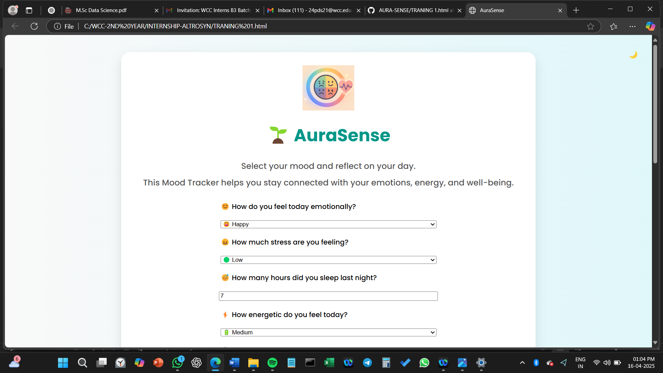

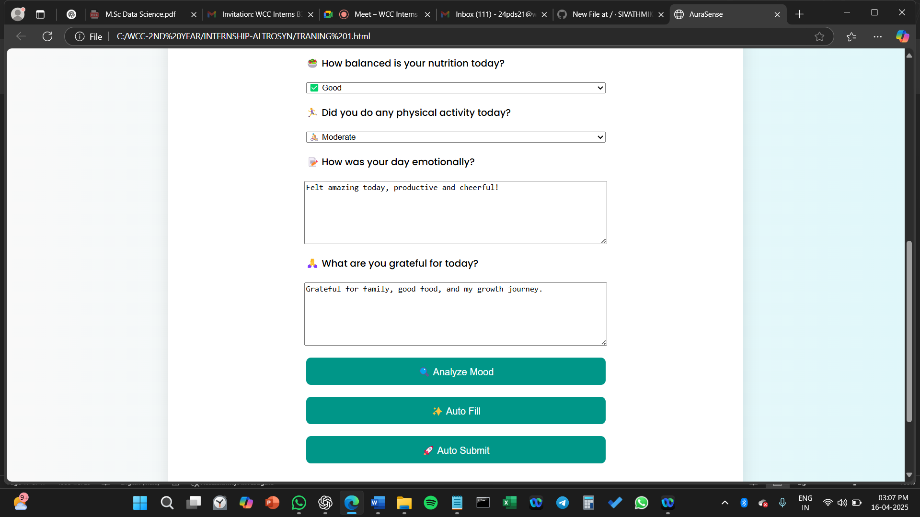

***USING AUTO-FILL OPTION***

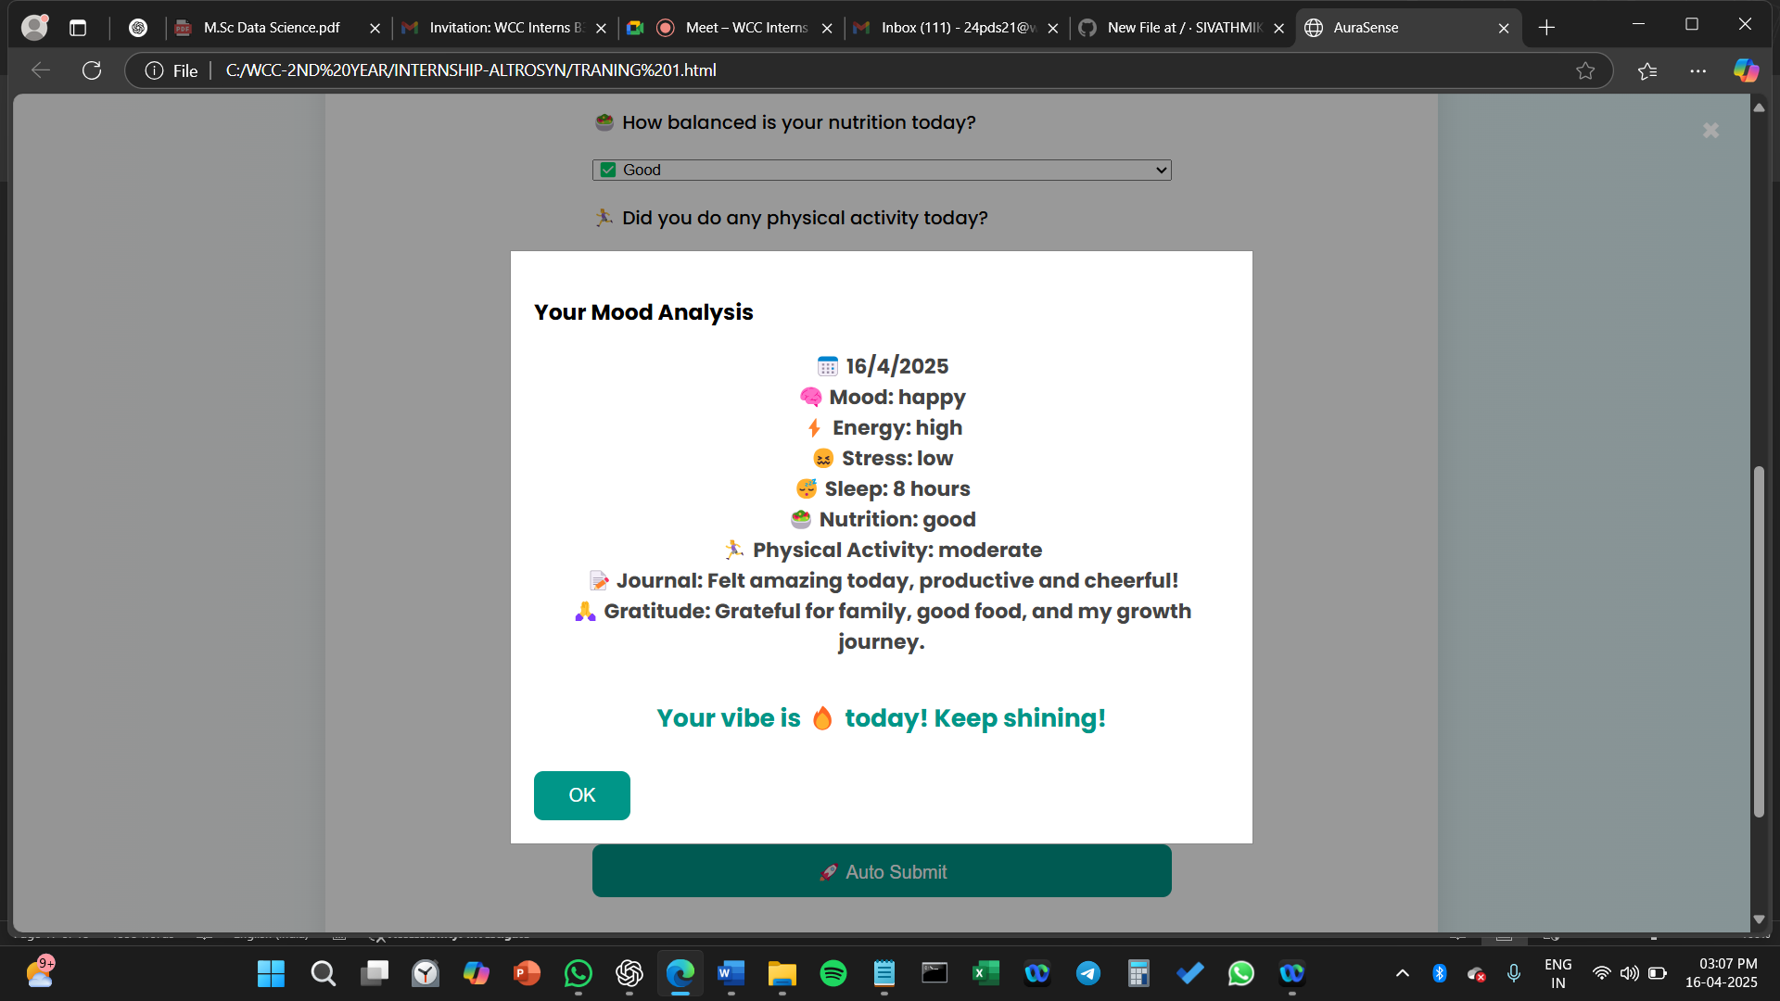

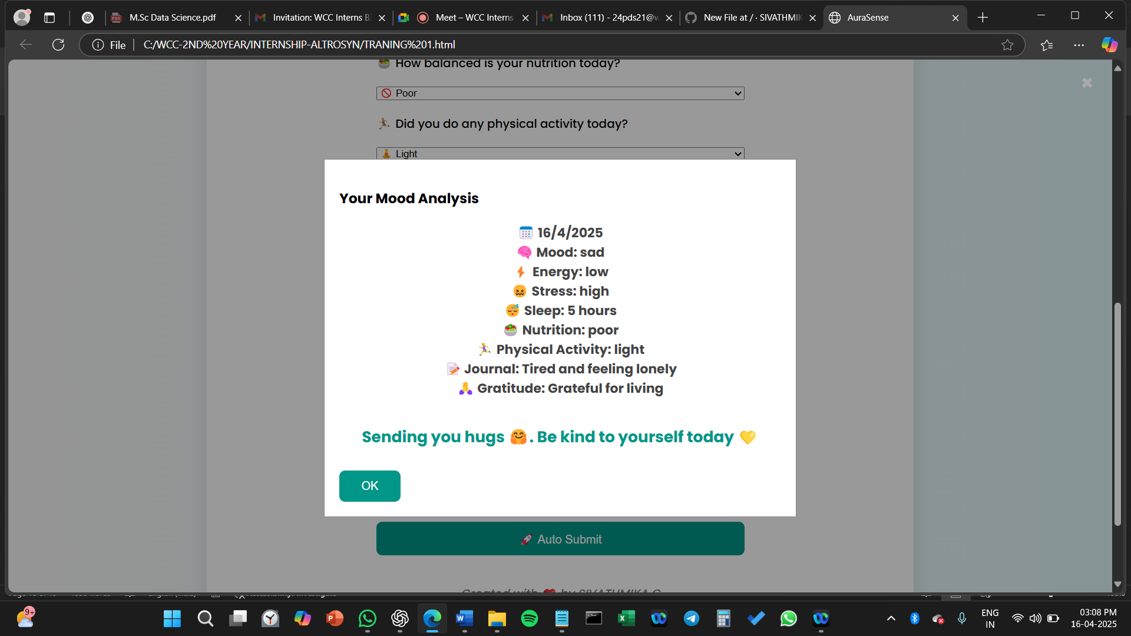

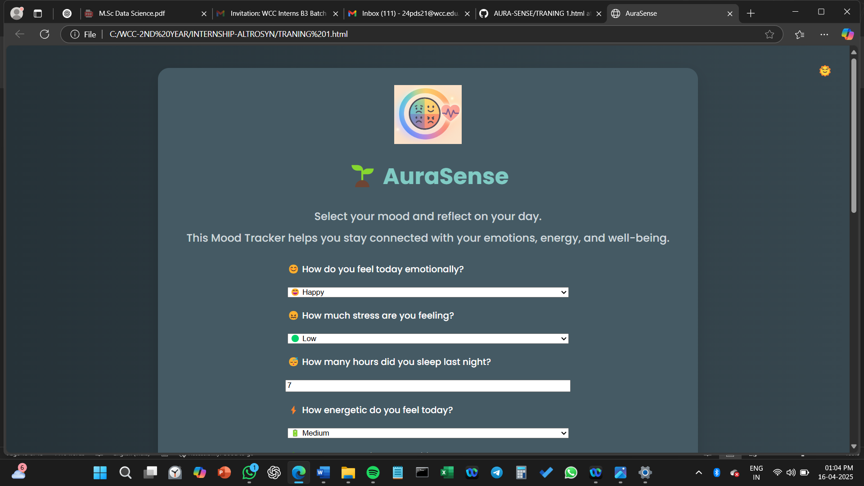**DARK MODE**